**AIM:** To create a Canteen menu to increase the ease of use and ease of functionality.

**PROCEDURE:**

1. Understand User Needs:

Research and gather insights from canteen users (students, staff, etc.) about their preferences and pain points.

2. Simplify the Layout:

Group items by categories (e.g., snacks, meals, beverages). Use large, easy-to-read fonts and icons for each category..

3. Mobile-First Design:

Make sure the menu is fully responsive for phones/tablets, as most users will likely access it via mobile. Add high-quality images of food items to make choices easier and more appealing.

4. Clear Feedback:

Provide immediate feedback after user actions, like confirming an order or adding an item to the cart.

5. Test and Iterate:

Continuously test with real users and iterate on the design based on feedback.

. 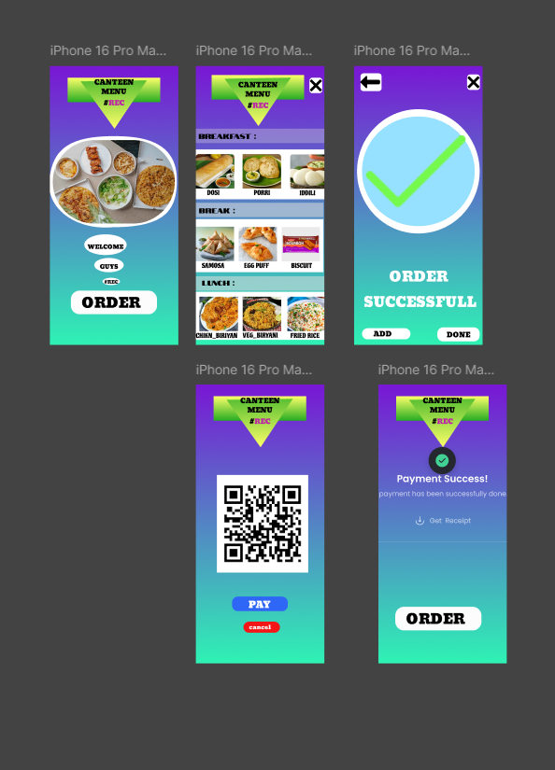

**RESULT:** Hence the design is completed and output is verified.